**NTUT**

**Operating System homework_1**

**指導老師 : 段裘慶 教授**

**班 級 : 電子所甲組**

**姓 名 : 臧英宏**

**學 號 : 109368085**

**民國109年十月八日**

1. Bravely and carefully discover your PC or Notebook computer (NB), and find out its specifications of CPU, DRAMS, HD, and DVD driver, then compared to your smartphone, in terms of as follows.  
   You need to take some pictures of your PC/NB with yourself, including the external/internal and CPU/DRAM views (opening the iron cover of PC).

|  |  |  |
| --- | --- | --- |
| **Items** | **My PC/NB** | **My Smart Phone** |
| 1. **CPU Type** | Intel i7-7700 | A12 |
| 1. **CPU Clocks** | 3.6-4.2 GHz | 2.49GHz |
| 1. **CPU core/thread** | 4/8 | 6 Cores |
| 1. **CPU Cache** | 8 MB | 8MB |
| 1. **DRAM** | 8 GB | 3GB |
| 1. **Hard Disk** | 1000.2 GB, 7200 RPM | 128GB |
| 1. **VGA card** | Intel® HD Graphics 630 | Apple 自身設計/ 4G |
| 1. **DVD driver** | 1, standard | No |

1. Try to repeatedly connect the Web Site “FM 99.7” (台北愛樂) or some media web (like YouTube) over the Internet until your PC/NB *shuts down* finally. Then *count* how many “FM 99.7 sites” (or YouTube) was connected.  
   In Exp.-1, your PC/NB is with ***full*** DRAMs on the motherboard, and then use ***half*** DRAMs in Exp.-2.  
   Take some pictures of the LCD screen on your PC/NB to showing the *work* and *frozen* status of the LCD screen in the two experiments, respectively.   
   Remind that you first must turn off your PC/NB, and then remove or plug the DRAMs from or into the specified bank on the motherboard.

|  |  |  |
| --- | --- | --- |
| **Items** | **Exp.-1** | **Exp.-2** |
| 1. **OS version** | MS Windows 10 | MS Windows 10 |
| 1. **DRAMs in total (GB)** | 16 GB | 8 GB |
| 1. **DRAMs available for App. (GB)** | **3.8GB** | **3.7GB** |
| 1. **(A) DRAM occupied by FM 99.7 (MB)** | **11498MB** | **4403MB** |
| 1. **(B) No. of FM99.7 sites be opening** | **322** | **197** |
| 1. **(A) / (B) in MB/App** | **35.7MB** | **22.6MB** |

**Due date: Oct. 13, 2020.**

拆卸前 拆卸後

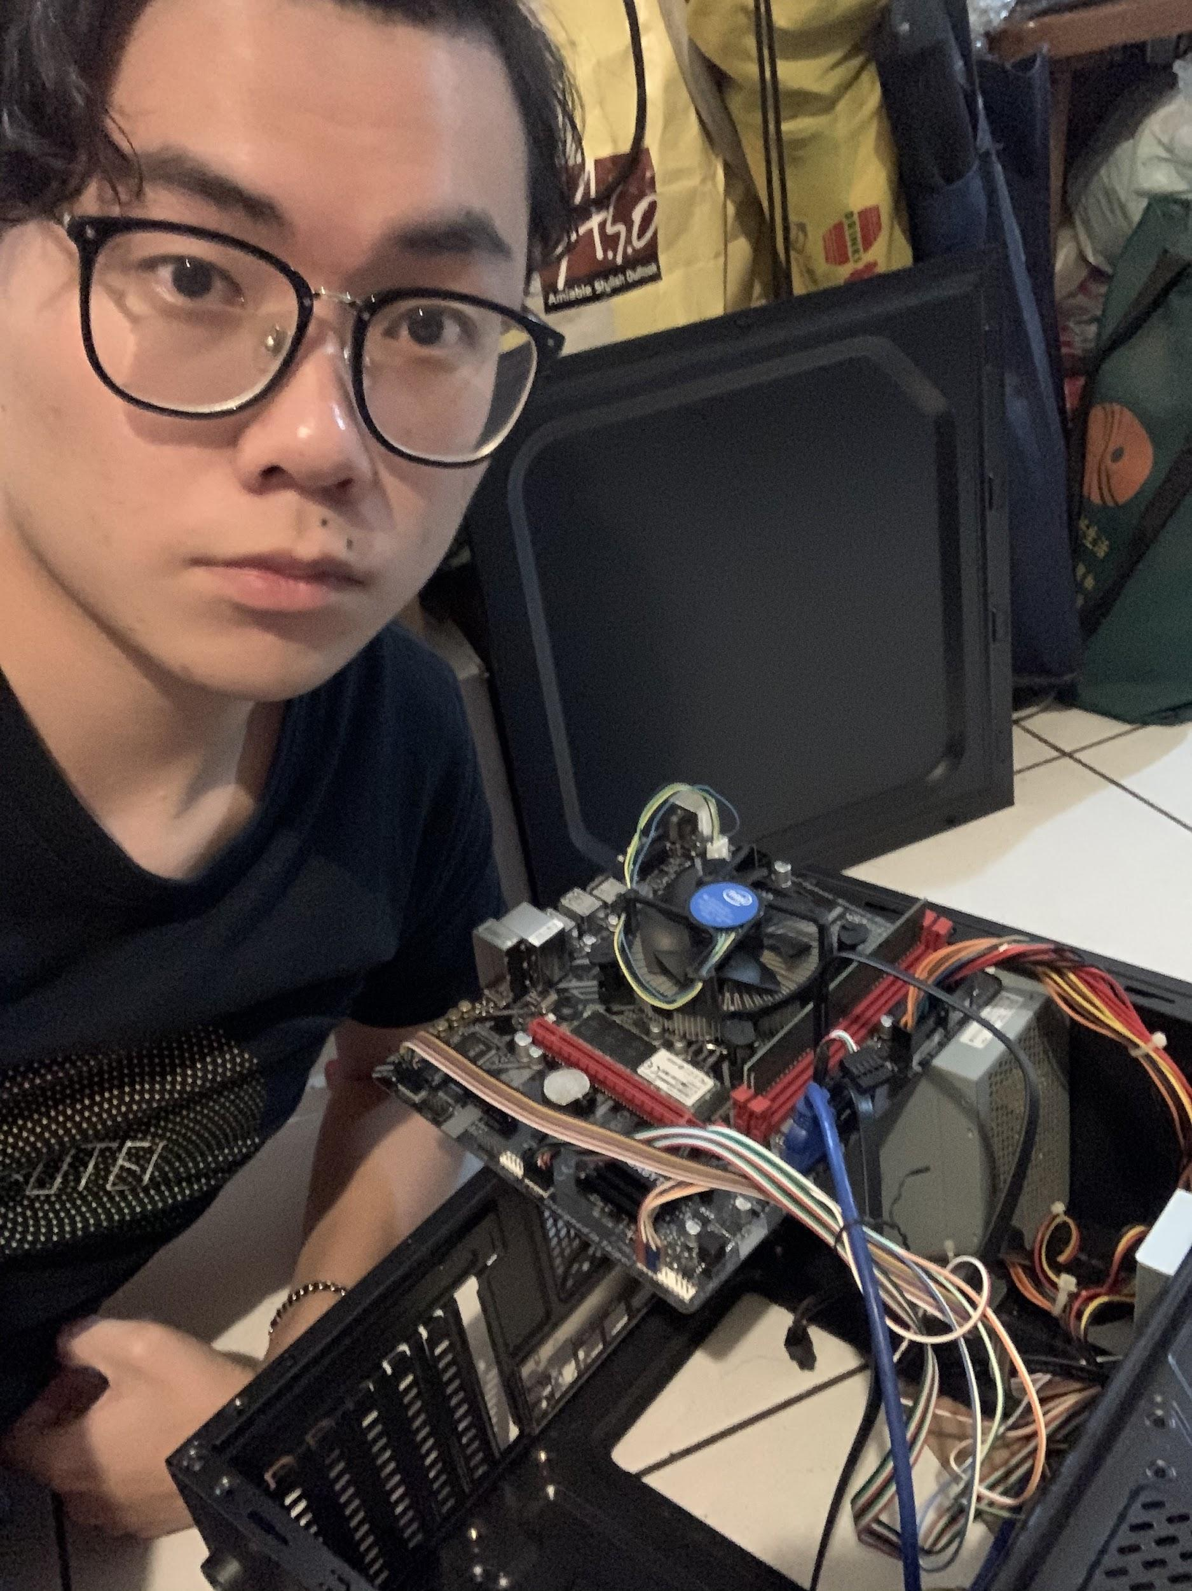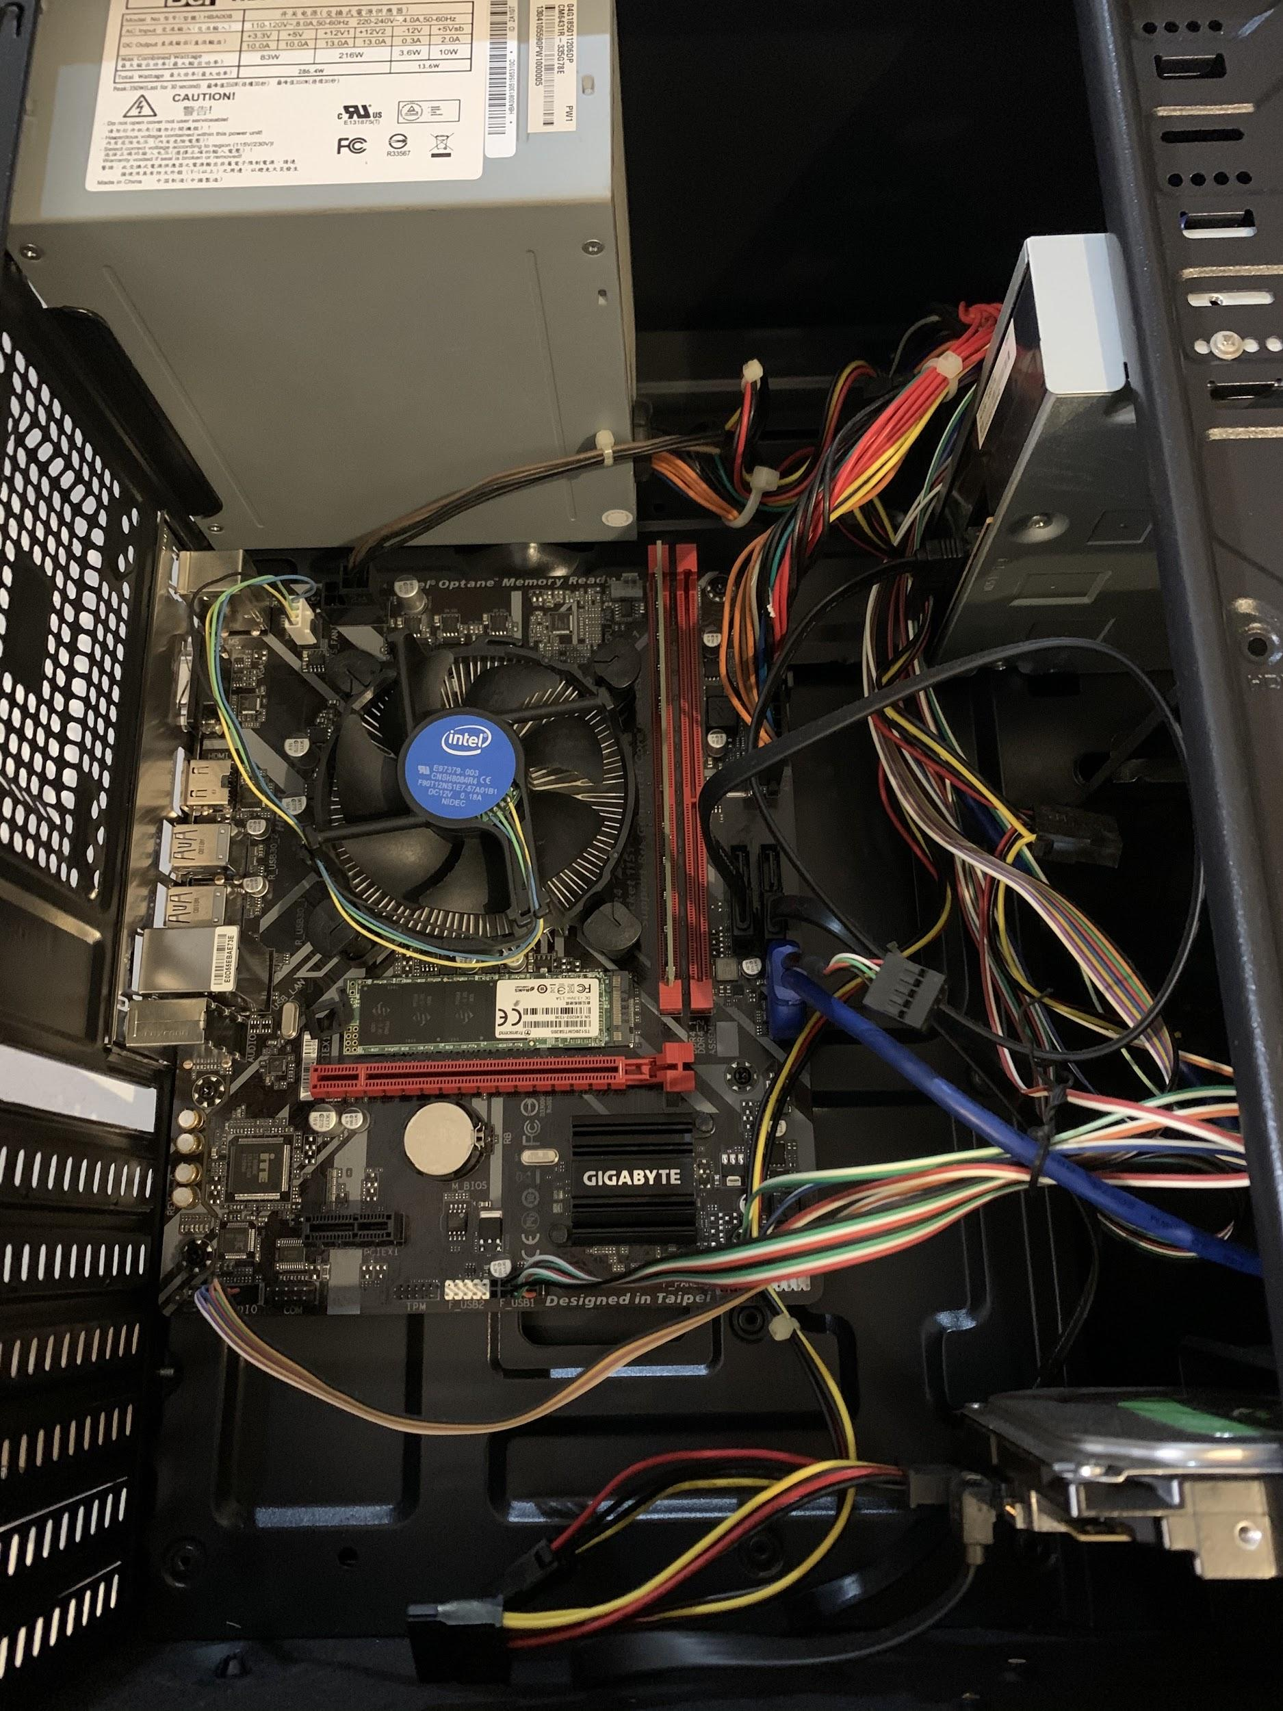

重新組裝 結構

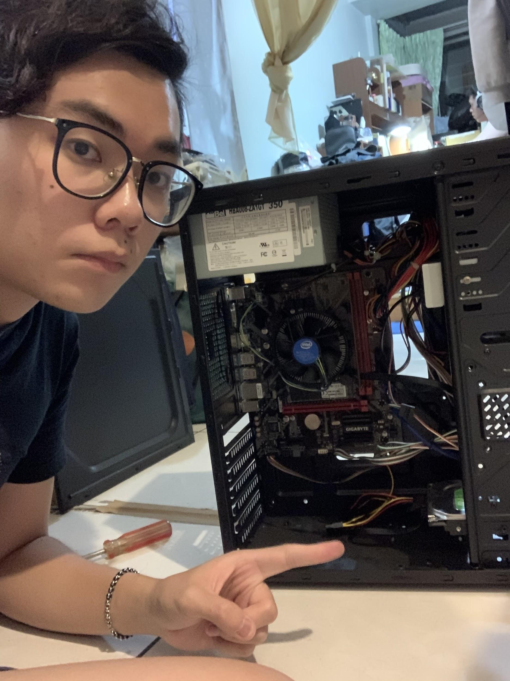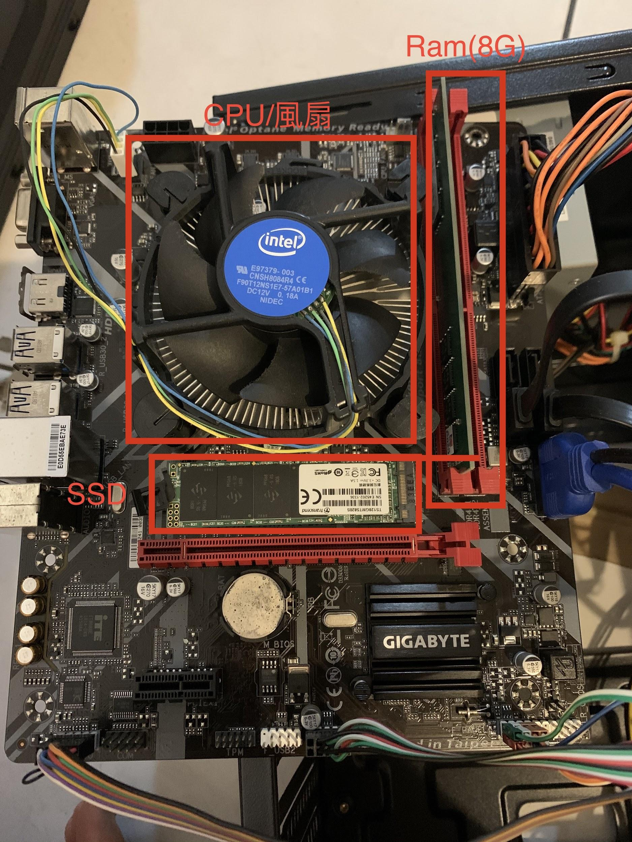

風扇/ram/ssd hard disk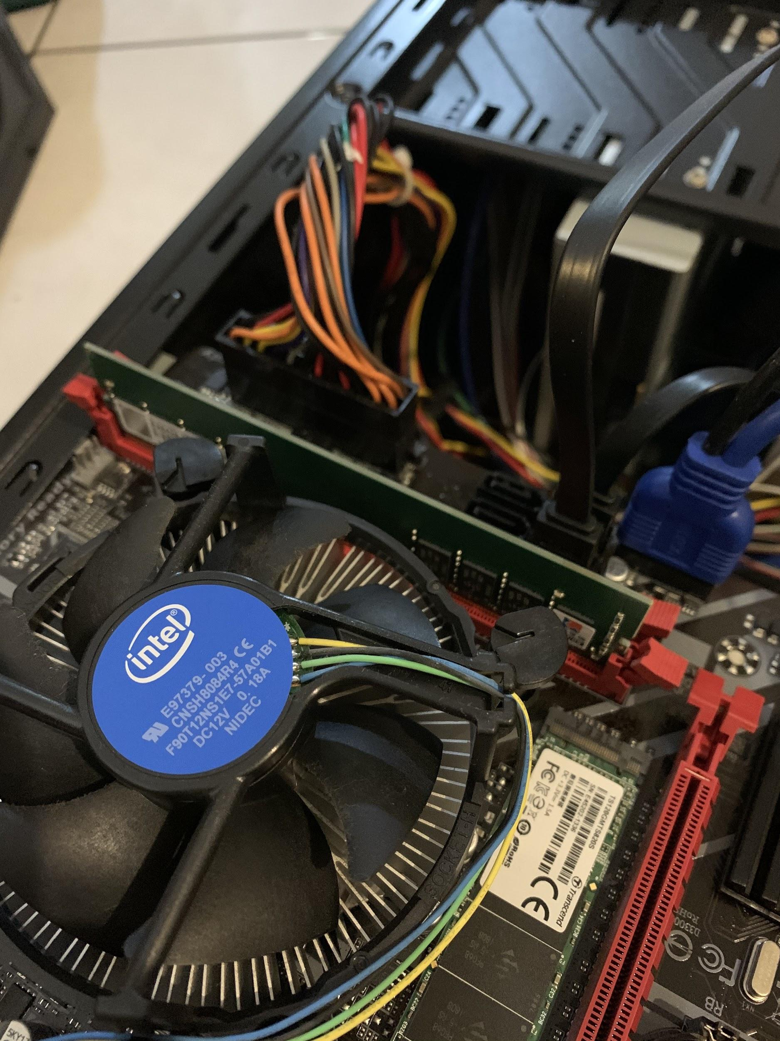

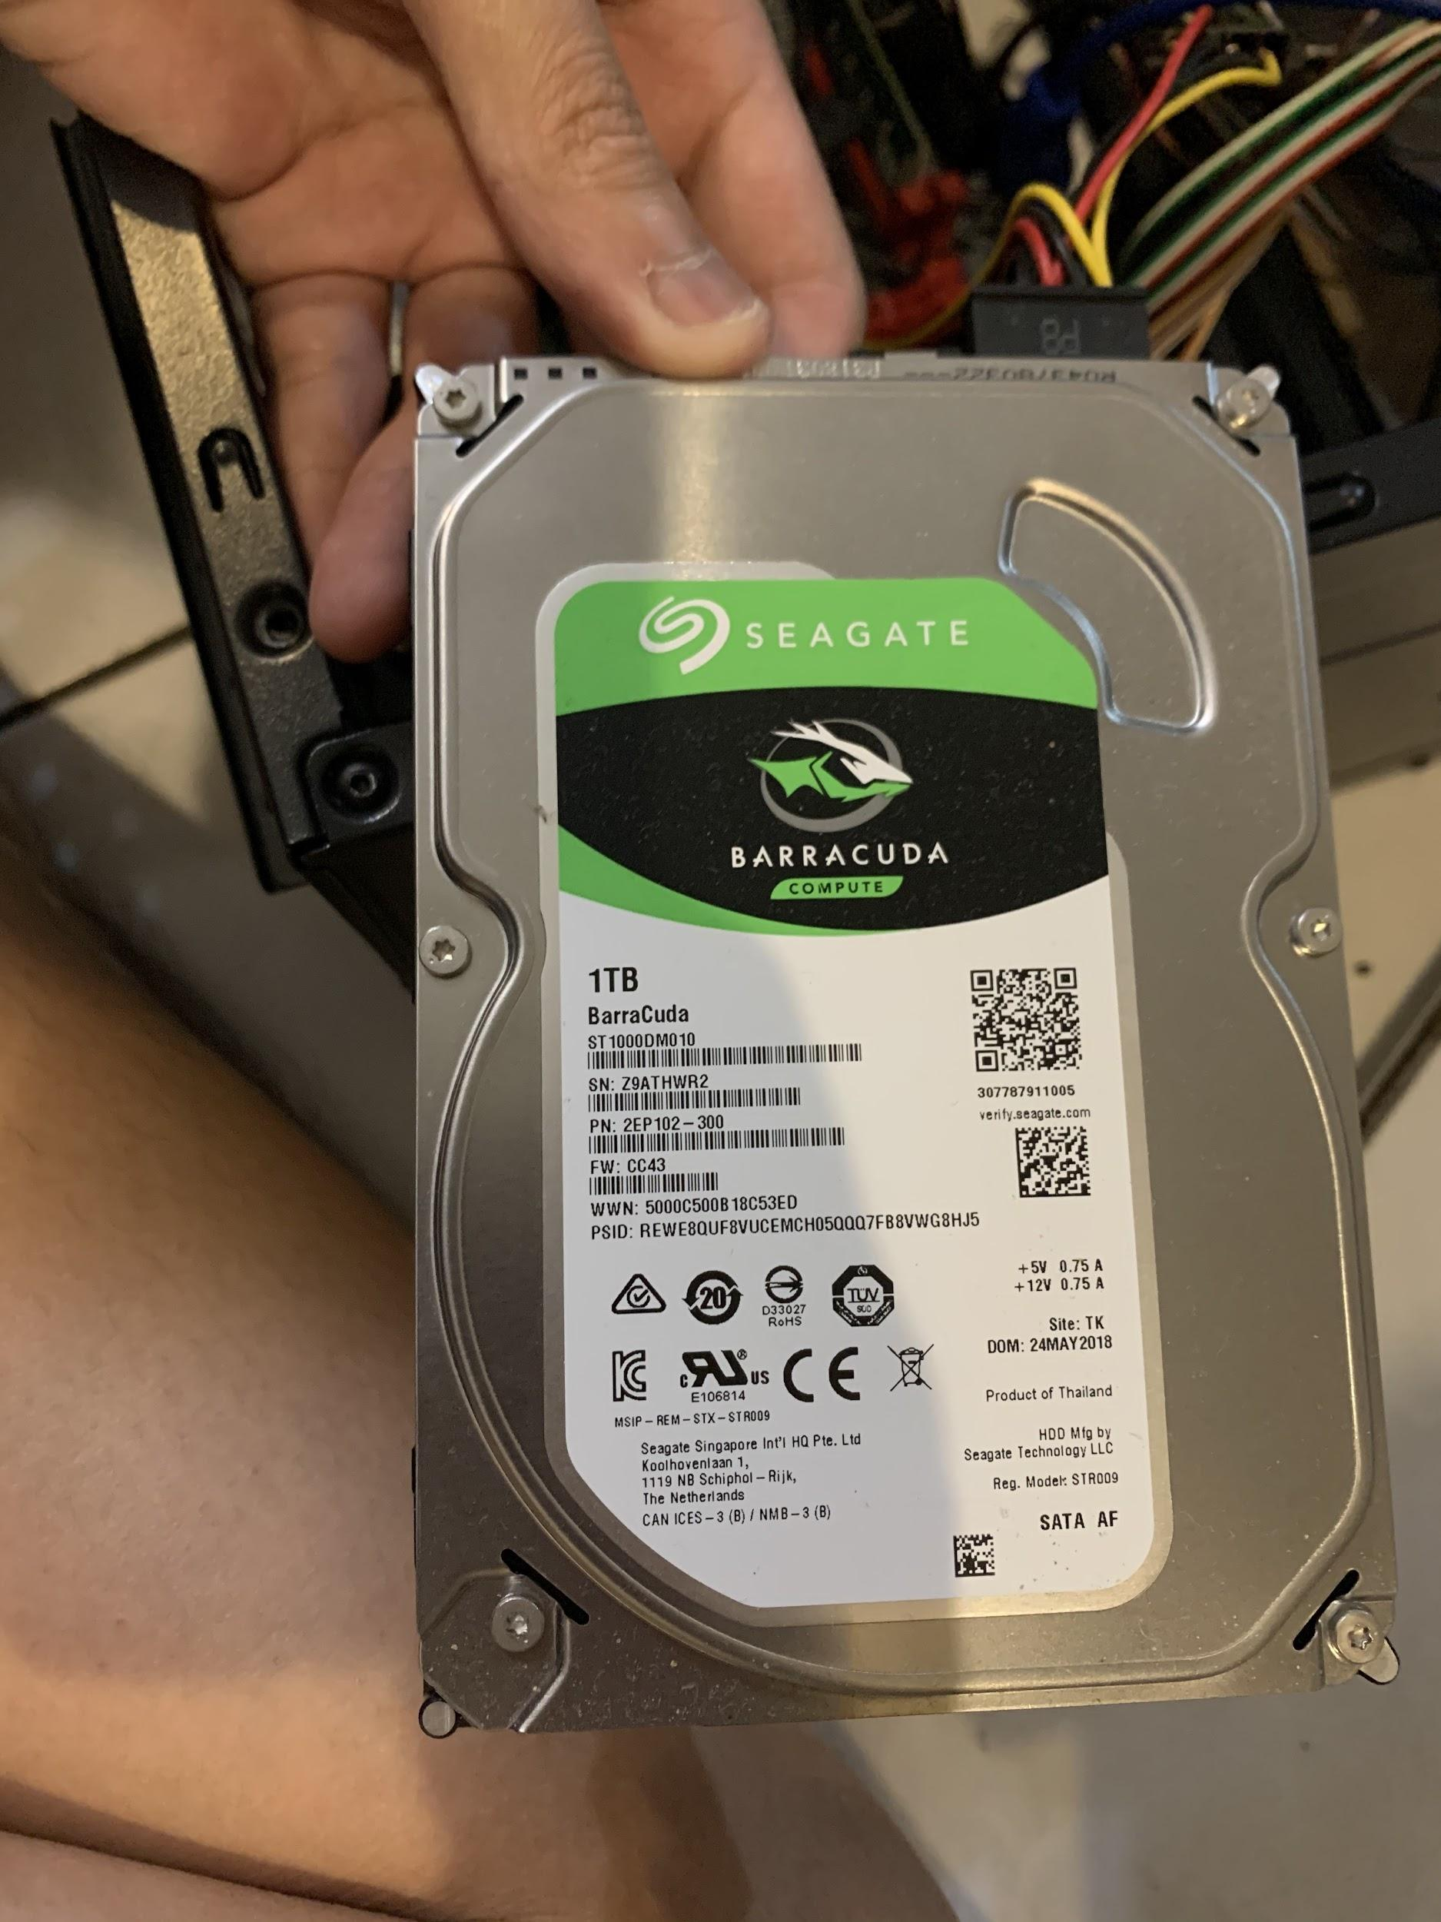

DVD driver ram

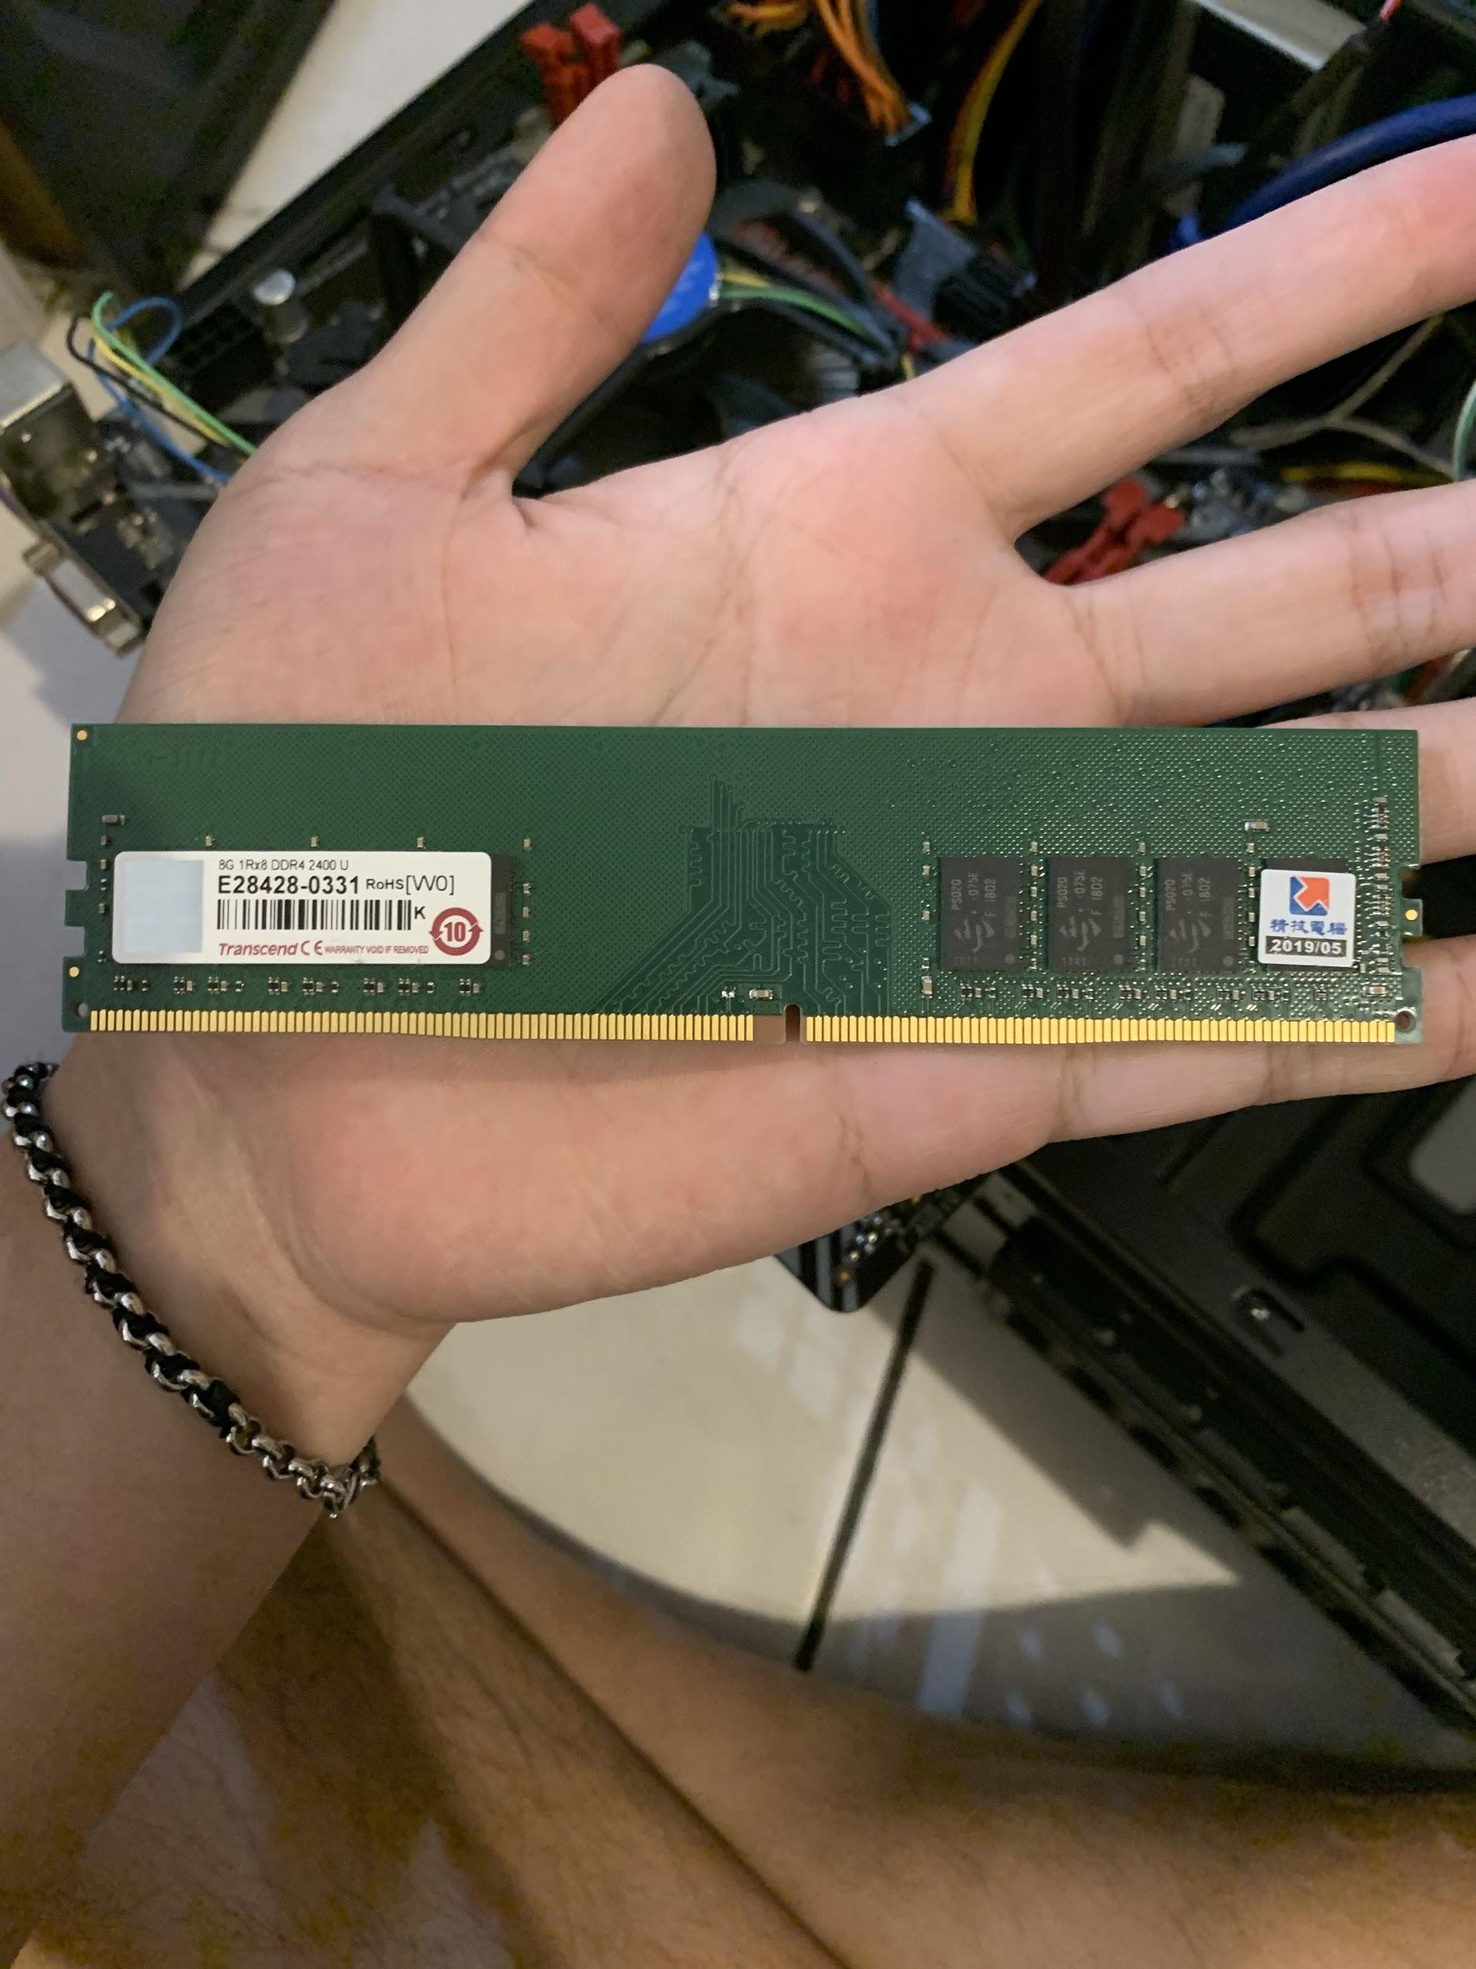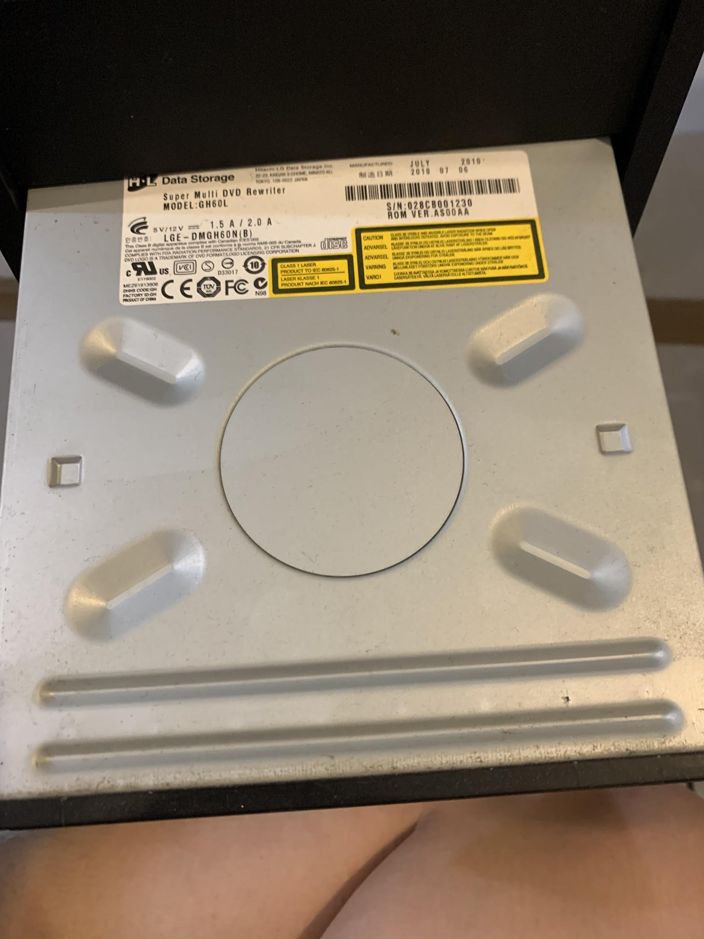

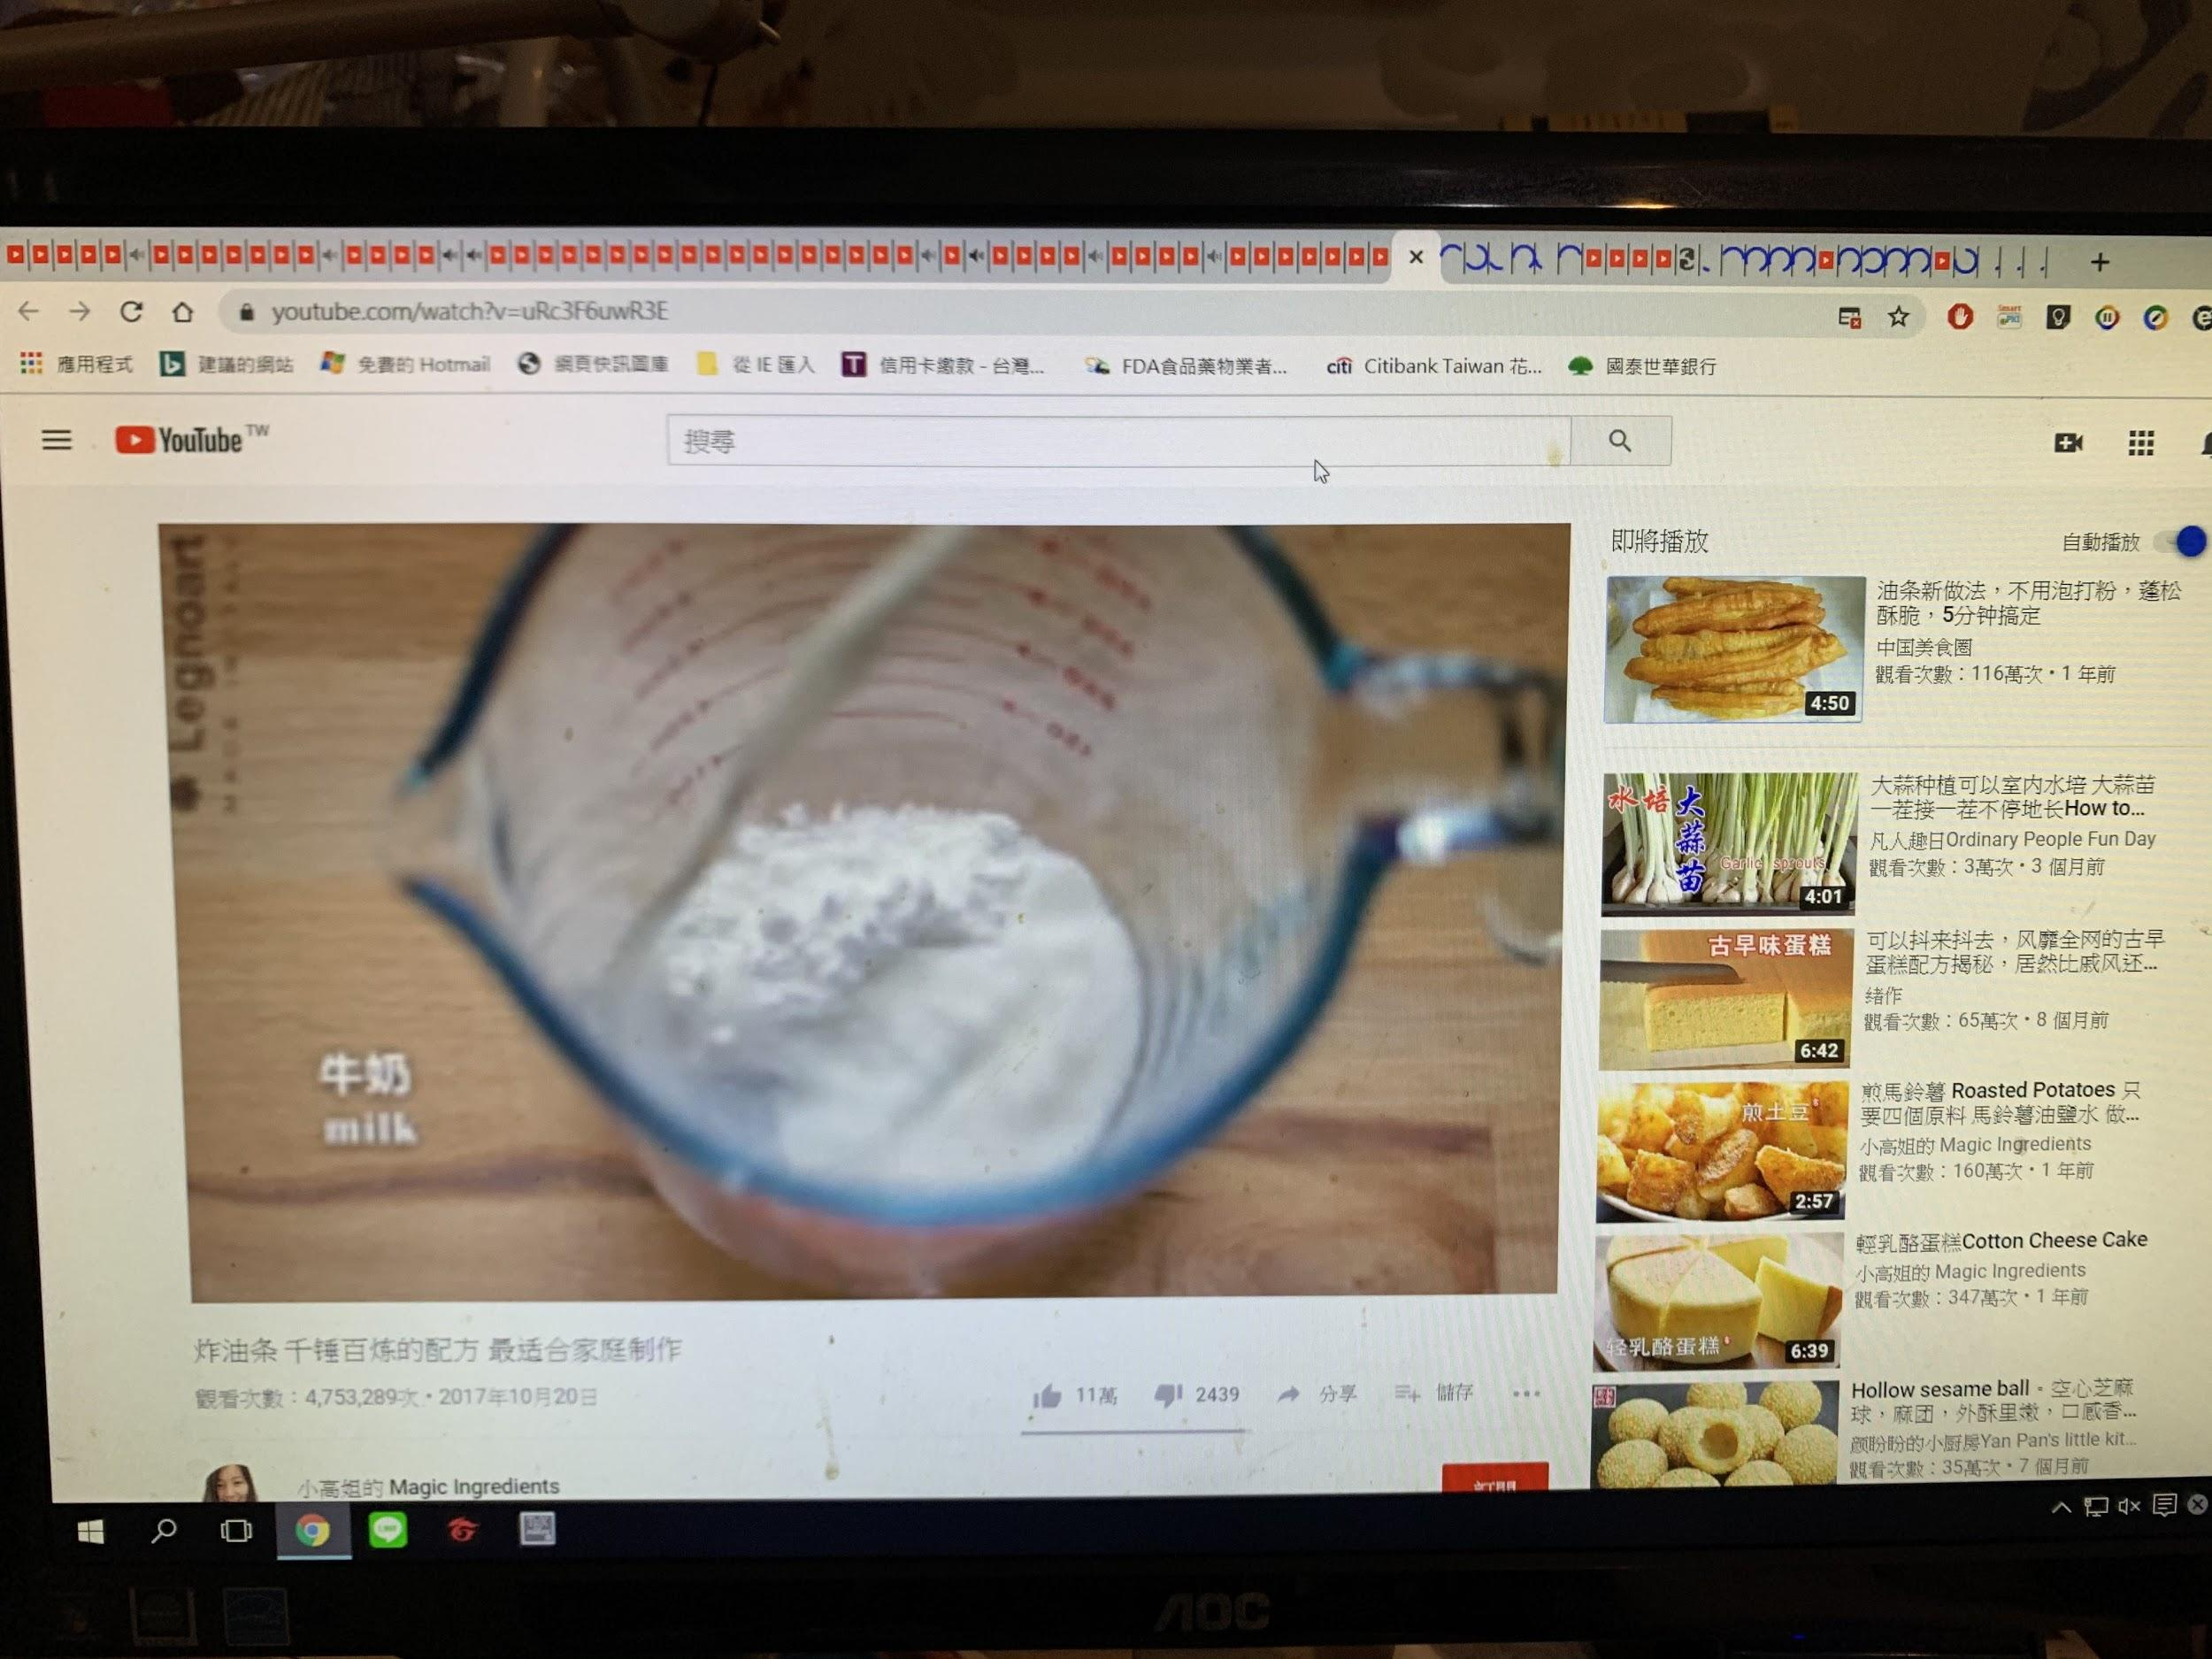youtube測試 (正常)

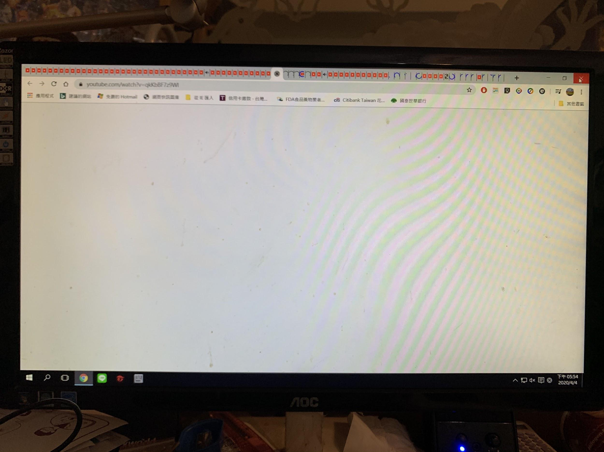youtube測試 (當機)

（約274個分頁）

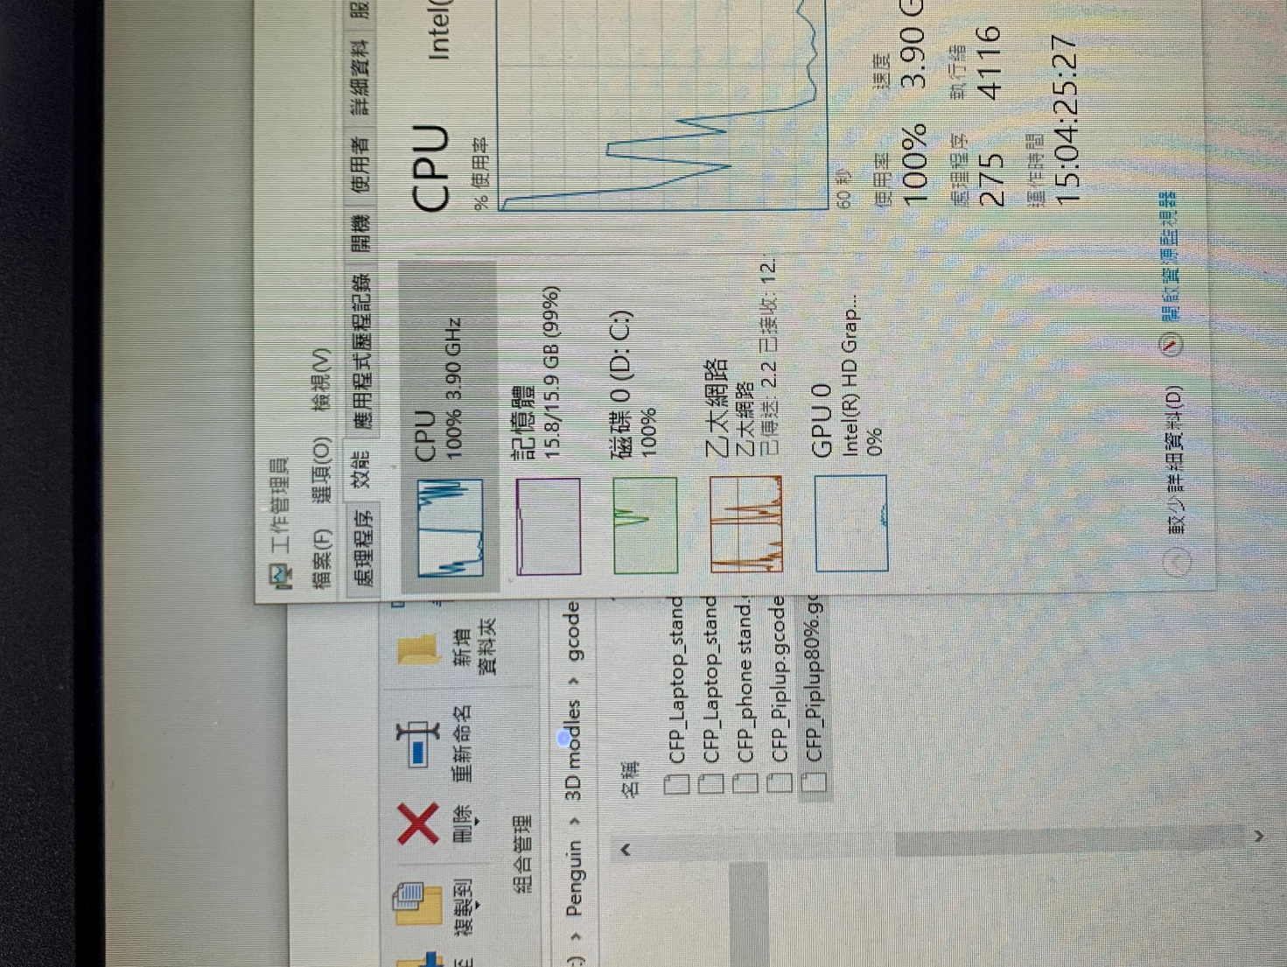

記憶體占滿，當機

**作業實作完成心得**

經過了此次作業實作，將久未處理塵封多時的機殼拆除，並整理內部線路以及清掃硬體結構，清出大量灰塵，並且發現內部線路有多處尚可有更好的規劃方式，也購買了束帶與固定器進行整理，由於電腦的硬體架構已過時，也規畫將在近期進行採購升級設備。

對於記憶體效能測試的部分，測試了運行雙通道以及一般模式的差異性，並從實驗得知了電腦的最大附載能耐，並了解到google chrome本身運行所佔的記憶體內容有了概念，在實驗結束後也對瀏覽器設定做了些調整，關閉某些不常使用的功能以及背景程式，成功減少了記憶體的占據量，能有更多的空間執行程式與提高效能，此為此作業給我的概念與幫助，獲益良多，受用無窮。